Name : Hrithvik kondalkar Roll:002211001088

1. List the names of employees and the name of their managers.

**SELECT MANAGER.ENAME EMPLOYEE, EMP.ENAME MANAGER FROM (SELECT ENAME, MGR FROM EMP) MANAGER, EMP WHERE MANAGER.MGR = EMP.EMPNO;**

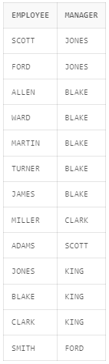

1. List the department names and the total number of employees in each department.

**SELECT G.NUM_OF_EMPLOYEES, DEPT.DNAME FROM (SELECT COUNT(ENAME) NUM_OF_EMPLOYEES, DEPTNO FROM EMP GROUP BY DEPTNO) G, DEPT WHERE G.DEPTNO = DEPT.DEPTNO;**

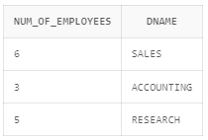

1. Show the employee names, job titles, and salaries of employees who work in departments located in 'CHICAGO' or 'DALLAS'.

**SELECT EMP.ENAME, EMP.JOB, EMP.SAL FROM (SELECT DEPTNO, DNAME FROM DEPT WHERE LOC = 'CHICAGO' OR LOC = 'DALLAS') DEPARTMENT,EMP WHERE EMP.DEPTNO = DEPARTMENT.DEPTNO;**

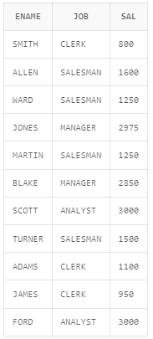

1. Show the department names and the highest salary among employees in each department.

**SELECT MSAL.HIGHEST_SAL, DEPT.DNAME FROM (SELECT MAX(SAL) HIGHEST_SAL,DEPTNO FROM EMP GROUP BY DEPTNO) MSAL, DEPT WHERE MSAL.DEPTNO = DEPT.DEPTNO;**

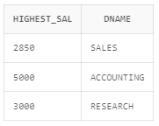

1. Display the employee names and their hire dates, sorted by hire date in descending order.

**SELECT ENAME, HIREDATE FROM EMP ORDER BY HIREDATE DESC;**

